Yahtzee

Chris Vasquez
Csc5_43952
June 7th, 2015

Psudo Code:

Declare: players, check, srand(time), round, temp, dice, menu, score, stop, name[players],ace[players],two[players],three[players],four[players], five[players],six[players],theKnd[players],forKnd[players], fulHse[players], smStrt[players], lgStrt[players], Yatzee[players], chnce[players];

Output: welcome.
Input: players.

Do while(round=13)
for(loop for each player)
cout the dice rolls,
for(loop for each dice)
cout roll again?
Cin y/n
if 'y' reroll, display the dice, error check
if 'y' again, reroll, display the dice, error check
else if 'n' display dice, error check
else if 'n' display dice, error check
do(while==15)//this is force a loop
switch
1.Aces
2.Twos
3.Threes
4.Four
5.Five
6.Six
7.Three Kind
8.Four Kind
9.Full House
10.Sml Straight
11.Lrg Straight
12.Yahtzee
13.Chance
14.Joker
have each selection error check
have each selection give score
make score == to selection array
make score ==0 after
swap on selections 7-12.
After all player have taken 13 turns
upper section adds all the 1-6 score for each player
Lower Section adds all the 7-13 score for each player
total adds upper and lower section for each player
compare each player to find winner
outut winner
end program
functions:
reRoll//designed to re roll the dice
dspDice//Displays all five dice to the player
Aces//Check Aces criteria
Twos//Check twos criteria
Three//Check three criteria
Four//Check four criteria
Five//Check five criteria
Six//Check six criteria
Three of a kind//After dices have been sequential swapped, check if three dices are the same
Four of a kind//After Dices have been sequential swapped, check if four dices are the same
Full house// After Dices have been sequential swapped, check is two dices matches, and the other three matches
Small straight// After Dices have been sequential swapped, check if the three possible sequential are present
Large straight// After Dices have been sequential swapped, check if the two possible sequential are present
Yahtzee// Check if all five dices are the same
Chance//Add all of the dice
Swap//swap till all dice are in a sequential order
Score Change// Change the score so there is no errors
Section Redo//Checks if player already have done this selection
input Validation//Check only proceed if char is 'y' or 'n'
number Validation//Check if number is 1-14.

How to play:

So the game will begin and will ask the user how many players that are present to play the game. Once the user enters the numbers of players, the program will then ask the name of each player. After all of the names are entered, the program will let player 1(their name will replace player 1) take their turn.

On the players turn, there will be 5 dice rolls. These dice rolls will display a number 1-6, representing the values of a standard die. After the player receives their dice rolls, they will be prompted to re-roll any dice, or keep the dice they already have. If they choose to re-roll, the game will ask if they want to re-roll each die separately. If the player decides to re-roll a die, then the computer will display a new value. If they choose to keep it, then it will display the current value. After the game has asked the player for each die, then the game will display the values of the dice you kept and changed. This will repeat one more time, and that will bring you to third and final turn.

When you decide to keep your dice(or after two re-rolls) you will be given the final values of the dice.
The game will then display a list of options to choose from. The player will choose a selection based on the current selection of their dice. If they have already done a selection, they will be prompted to choose another selection. Each selection will have conditions that the values of the dice have to pass. If they do not pass a selections condition, a score of zero will be issued to that selection..After every player does 13 rounds, the computer will add all of the upper sections of the players, and the lower sections. If a player gets more than 63 points on the top, then they will get a bonus of 35 points. A total for all players is calculated, and then a winner is declared with the most points.
Below, explains all the points and requirements for each selection.
(note, this next section is taken straight from http://grail.sourceforge.net/demo/yahtzee/rules.html)
In the upper scores, you total only the specified die face. So if you roll:
and score in the Threes category, your total for that entry would be 9. This same roll would yield zero points if you scored it in the Aces (Ones), Twos, or Fives category, four points if you scored it in the Fours category, or six points if you scored it in the Sixes category.
When the game is over, if you score 63 or more upper points (an average of 3 die faces per category), you will get an upper bonus of 35 points. Of course do don't need to score exactly three die faces in each upper category to get the bonus, as long as the upper total is at least 63.

Lower Scores
In the lower scores, you score either a set amount (defined by the category), or zero if you don't satisfy the category requirements.

3 and 4 of a Kind
For 3 of a Kind, you must have at least three of the same die faces. If so, you total all the die faces and score that total. Similarly for 4 of a Kind, except that you must have 4 of the 5 die faces the same. So for example, if you rolled:
you would receive 20 points for 3 of a Kind, but zero points for 4 of a Kind.

Straights
Like in poker, a straight is a sequence of consecutive die faces; a small straight is 4 consecutive faces, and a large straight is 5 consecutive faces. Small straights score 30 points and large straights score 40 points. Thus, if you rolled:
you could score either a small straight or a large straight, since this roll satisfies both.

Full House
Again as in poker, a Full House is a roll where you have both a 3 of a kind, and a pair. Full houses score 25 points.

Yahtzee
A Yahtzee is a 5 of a Kind (i.e. all the die faces are the same), and it scores 50 points. If you roll more than one Yahtzee in a single game, you will earn a 100 point bonus for each additionalYahtzee roll, provided that you have already scored a 50 in the Yahtzee category. If you have not scored in the Yahtzee category, you will not receive a bonus. If you have scored a zero in theYahtzee category, you cannot receive any bonuses during the current game.
You can also use subsequent Yahtzee's as jokers in the lower scores section, provided the following criteria have been satisfied:
- You have scored a zero or 50 in the Yahtzee category.
- You have filled the corresponding category in the upper scores section. For example, if you have rolled:
the Fives category must also be filled.
If this is the case, you can use the Yahtzee as a joker to fill in any lower scores category. You score the category as normal. Thus for the Small Straight, Large Straight, and Full House categories, you would score 30, 40, and 25 points respectively. For the 3 of a Kind, 4 of a Kind, and Chance categories, you would score the total of the die face.

Chance
Chance is the catch-all roll. You can roll anything and you simply total all the die faces values.

FlowChart
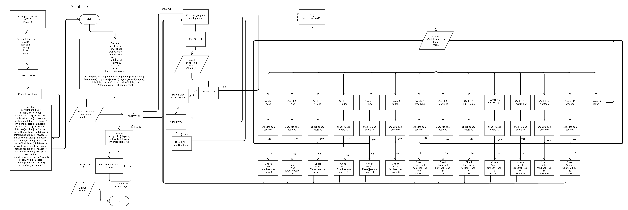

Work cited

- "The Rules of Yahtzee." The Rules of Yahtzee. N.p., n.d. Web. 08 June 2015.
http://grail.sourceforge.net/demo/yahtzee/rules.html

